**Modual-7: Jquery basic and effects**

(Q.1) What is JQuery?

Ans:

=>jQuery is a JavaScript library.

=>HTML document traversal and manipulation, as well as event handling, animation, and Ajax interactions.

=>It makes it easier to work with HTML documents, handle events, create animations, and make asynchronous HTTP requests.

=>Example:-

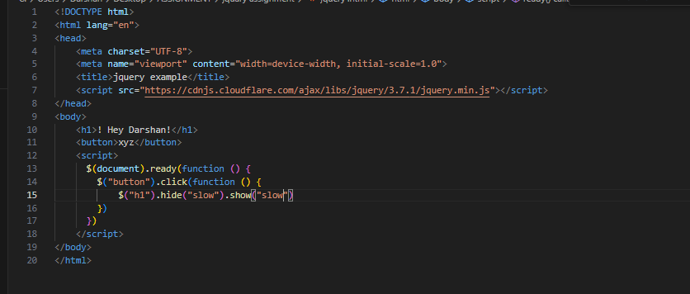

Q.2) How to Apply CSS Using JQuery, How to Add Class and Remove Class in Jquery, JQuery Animation?

Ans:-

1)Applying CSS Using JQuery:

Example:

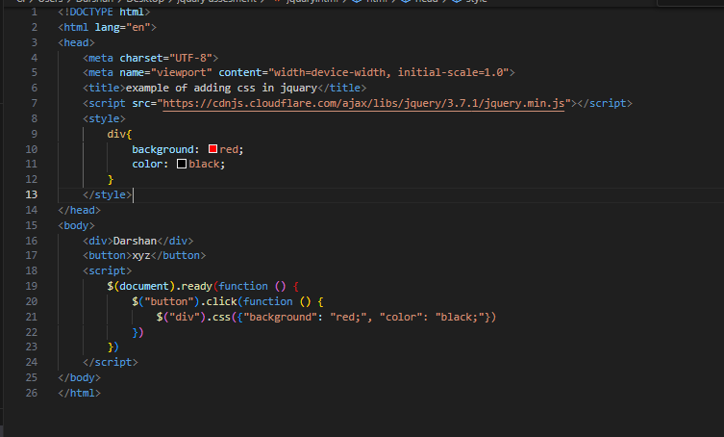

2)Adding and Removing Classes:-

Example:-

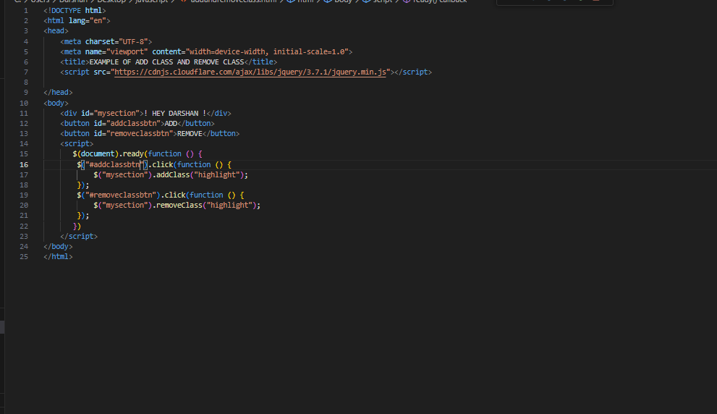

3)JQuery Animation:-

Example:-

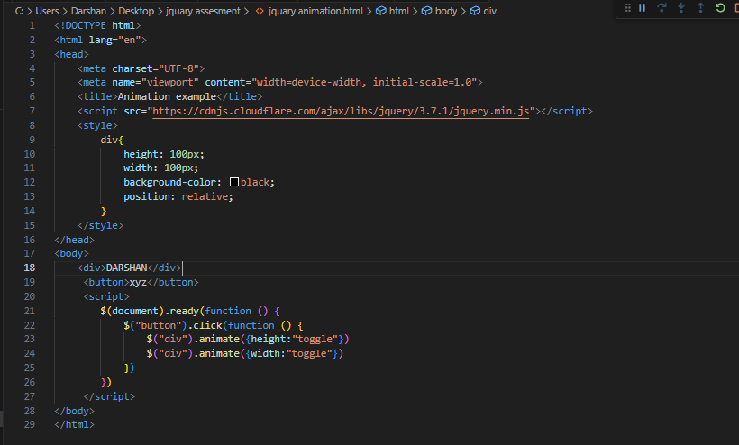

Q.3) How to create slider with animation?

Ans:

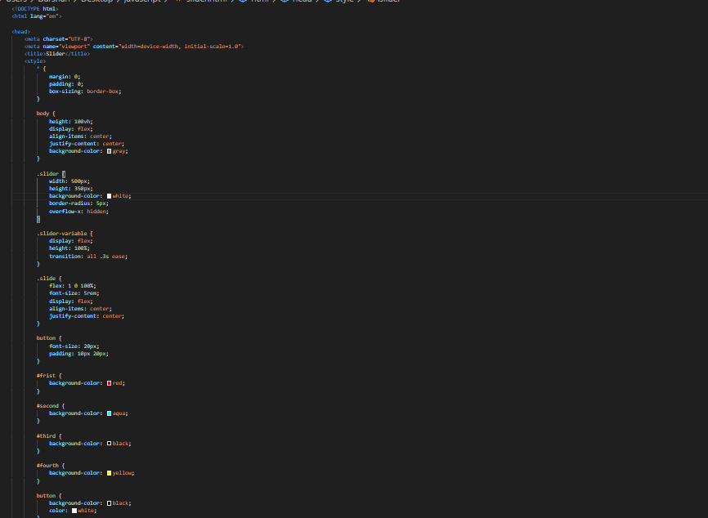

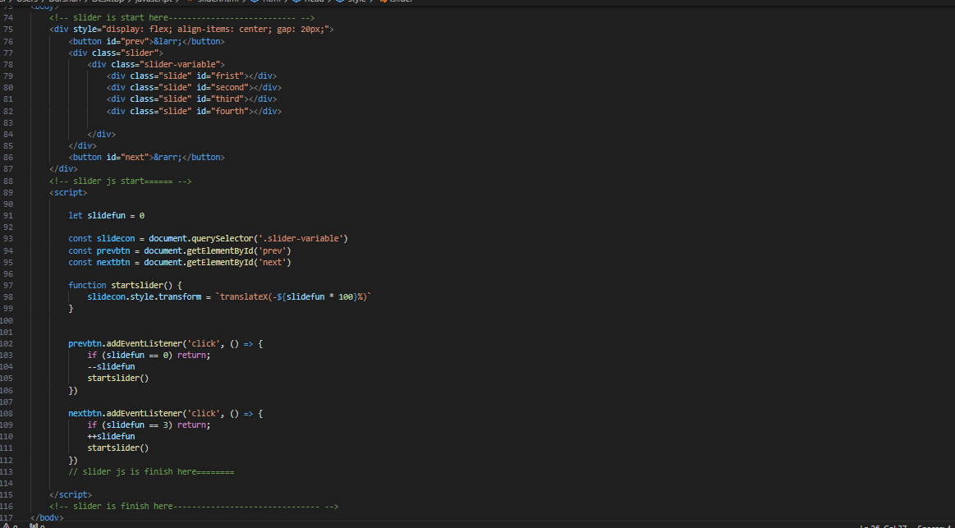

Q.4) Event bubbling tickling example…

Ans:

